Dr. A. Q. Khan Institute of Computer Science & Information Technology


Lab no. 04
Artificial Intelligence (Lab)
Submitted to:
MAM HAJRA
Submitted by:
Tehzeeb (232101006)
Department:
BSCE-7.
Date:
September 21, 2026

Coding/logic | Response | Data processing & visualization | Accuracy | Outcome/Result
04 | 04 | 04 | 04 | 04
LINK: https://github.com/Tehzeb/AI-LAB/blob/main/main.py

Question 1 — Titanic Dataset
Practice data preprocessing techniques using the Titanic Dataset and Scikit-learn. The dataset contains passenger information such as age, gender, passenger class, fare, and survival status. Perform data cleaning, missing-value handling, categorical feature encoding, feature selection, feature scaling, and train-test splitting.
Analyze how different types of data require different preprocessing techniques and prepare the dataset for a Machine Learning classification problem.

Task Requirements
- Load the Titanic Dataset using Pandas.
- Explore and document:
  - Number of records and features
  - Feature names
  - Data types
  - Target variable
  - Missing values
  - Duplicate records
  - Basic statistical information
- Perform data cleaning:
  - Identify missing values.
  - Handle missing values in appropriate columns.
  - Check and remove duplicate records if required.
  - Verify the cleaned dataset.
- Identify the input features and target variable:
  - Input features (X): passenger-related attributes.
  - Target variable (y): survival status.
- Select relevant features for Machine Learning.
- Identify categorical and numerical features.
- Apply categorical encoding using an appropriate Scikit-learn technique such as OneHotEncoder.
- Apply missing-value handling using SimpleImputer.
- Apply feature scaling to appropriate numerical features using:
  - StandardScaler
  - or MinMaxScaler
- Split the dataset into:
- Training data
- Testing data
- Use an appropriate train-test ratio, such as 80:20.
- Create a Scikit-learn ColumnTransformer to apply different preprocessing techniques to numerical and categorical features.
- Create a complete Scikit-learn Pipeline that combines preprocessing steps.
- Display the shape of the final training and testing datasets.
- Analyze the results and explain:
- Why missing values needed to be handled.
- Why categorical variables needed encoding.
- Why numerical features may require scaling.
- Why train-test splitting is necessary.
- How the processed Titanic dataset can be used for a classification Machine Learning model.

SOLUTION:
Titanic Dataset Preprocessing
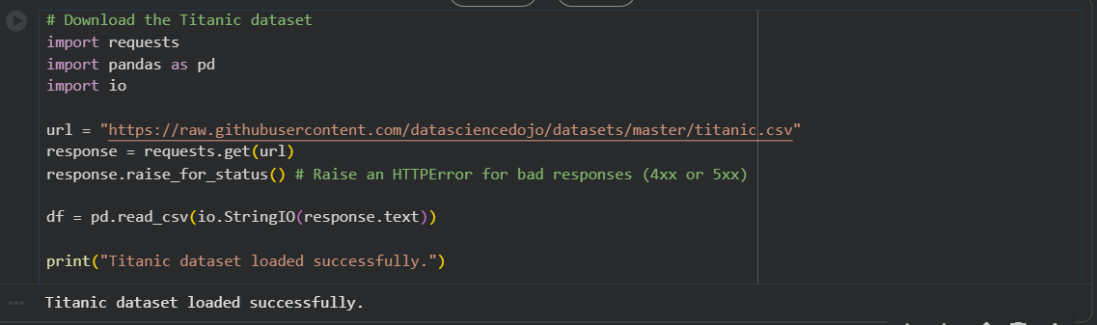

2. Explore and document the dataset
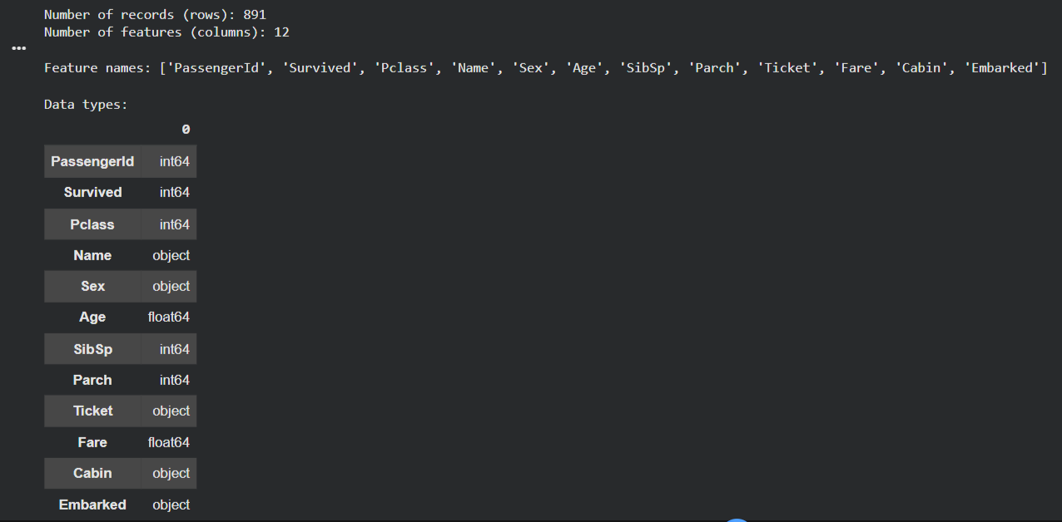
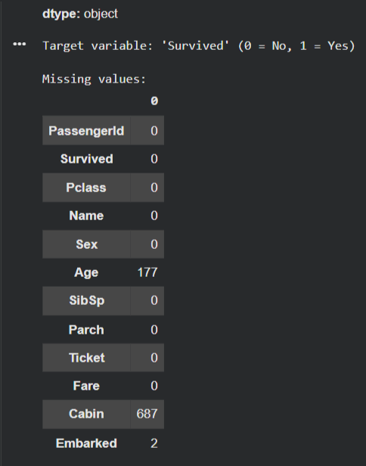
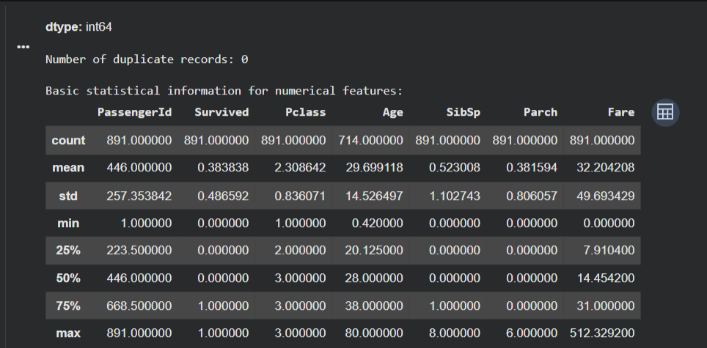
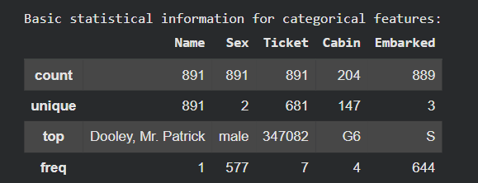

3. Perform data cleaning
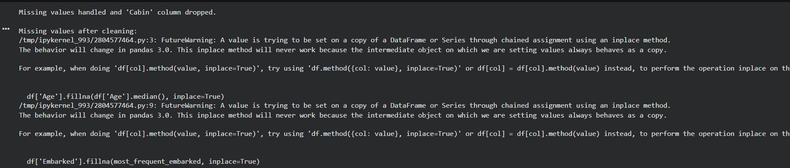
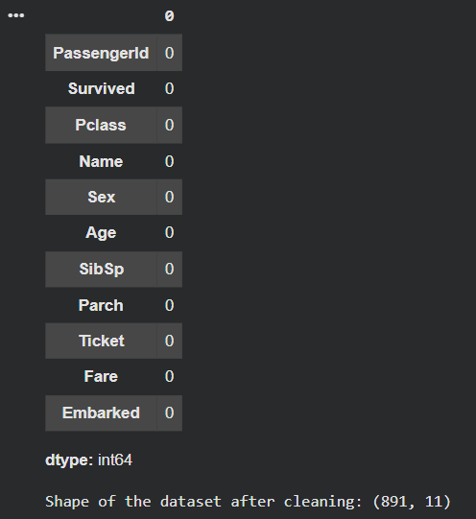

4. Identify the input features and target variable
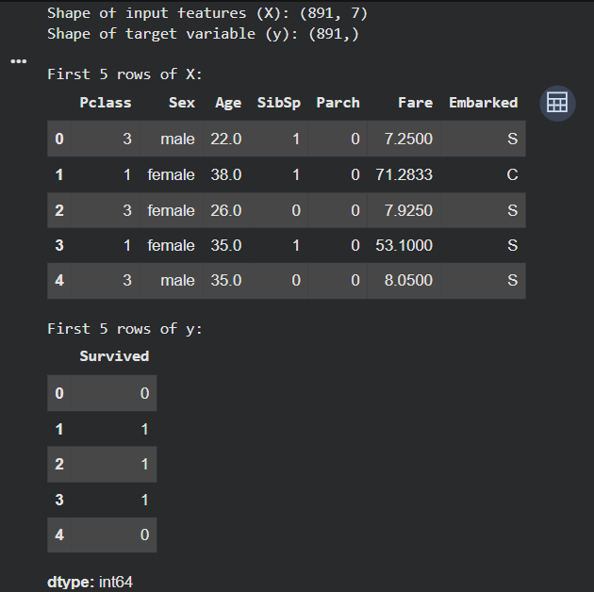

5. Select relevant features for Machine Learning.

6. Identify categorical and numerical features
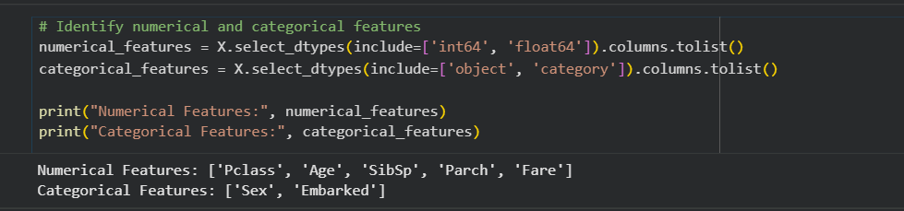

7., 8., 9., 12., & 13. Apply preprocessing techniques using ColumnTransformer and Pipeline
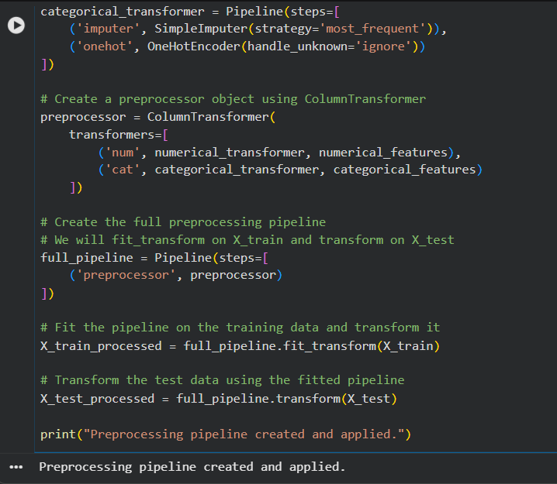

10. & 11. Split the dataset into Training and Testing data with an 80:20 ratio
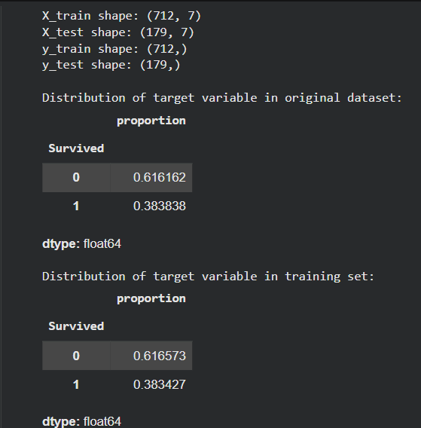
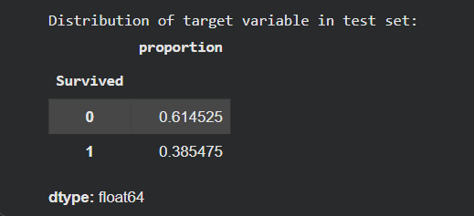

14. Display the shape of the final training and testing datasets
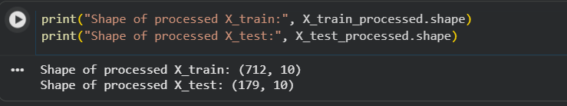
15. Analyze the results and explain
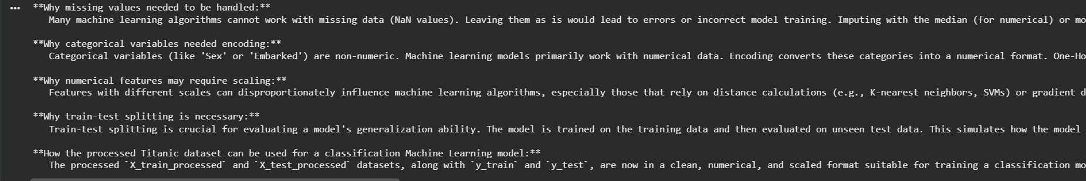
BAR CHART AGE DISTRIBUTION OF PASSENGERS BY SURVIVAL:
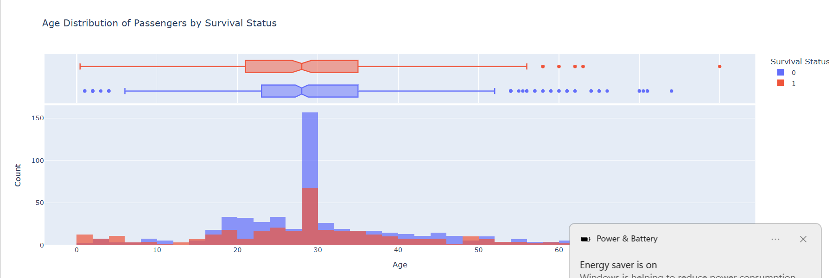
This histogram shows the distribution of ages, colored by survival status. The marginal box plot gives you a quick summary of age distributions for survivors and non-survivors. You can zoom and pan to explore specific age ranges.

Scatter plot visualizes the relationship between Fare, Age, and Survival, with the size of the points representing Pclass:
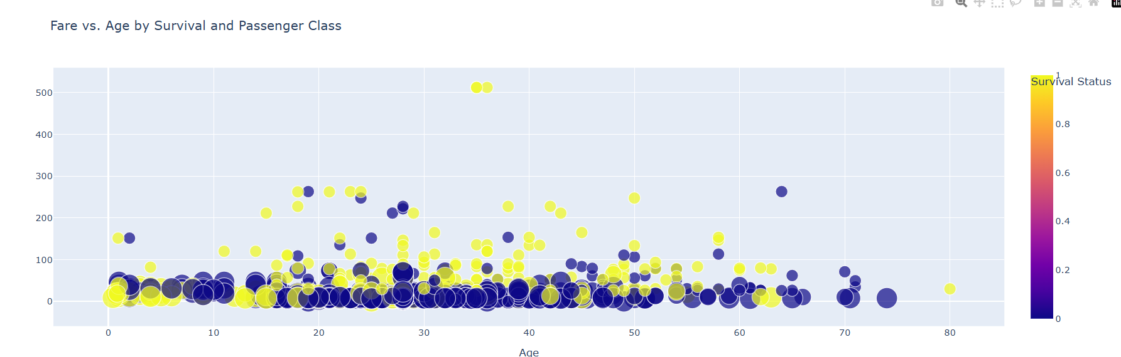

Interactive 3D Scatter Plot: Age, Fare, and Pclass
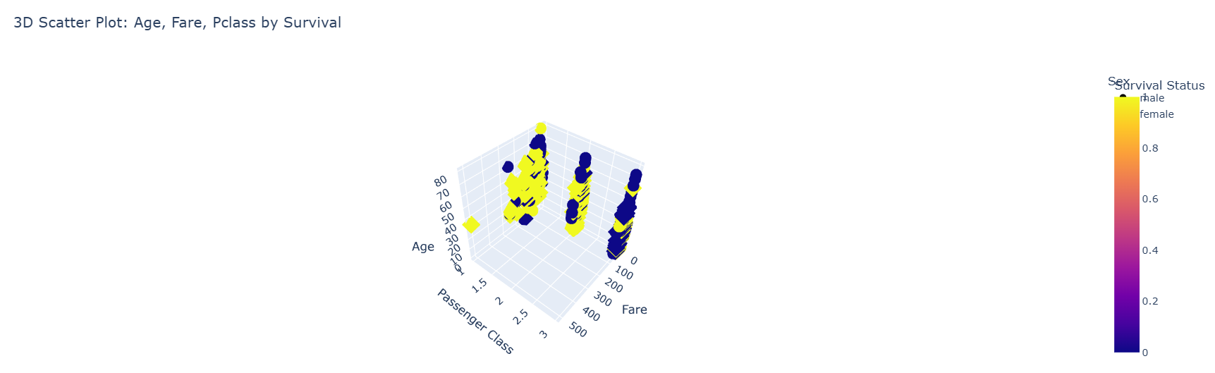

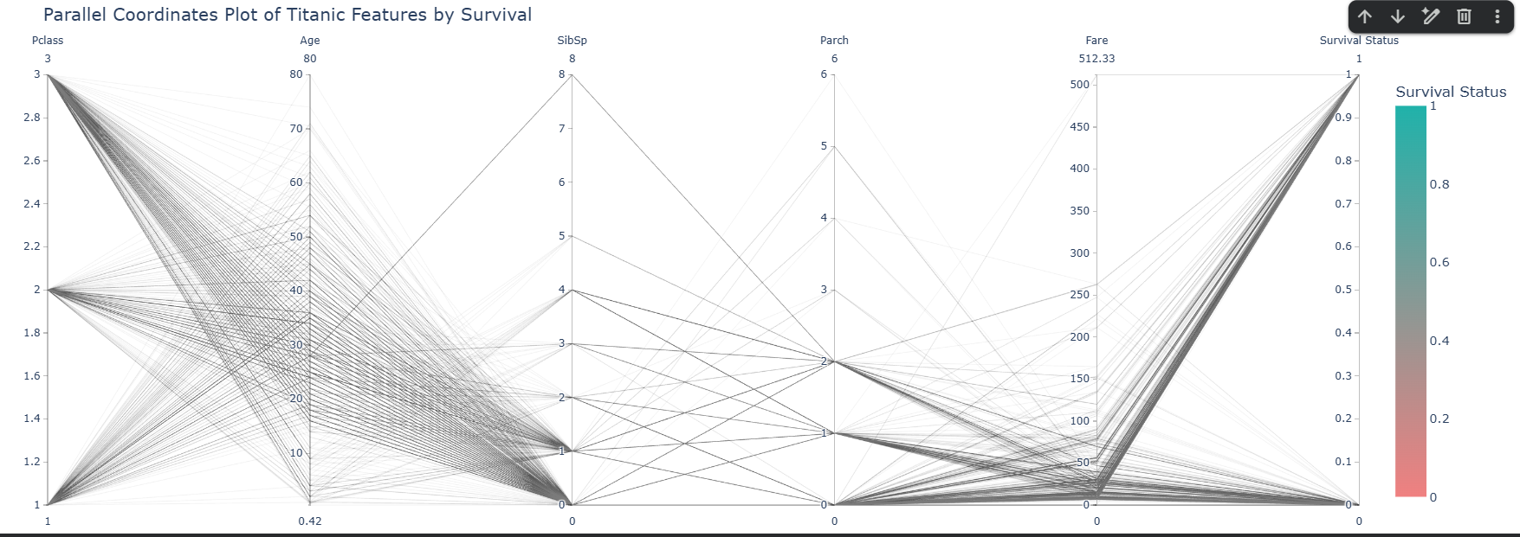

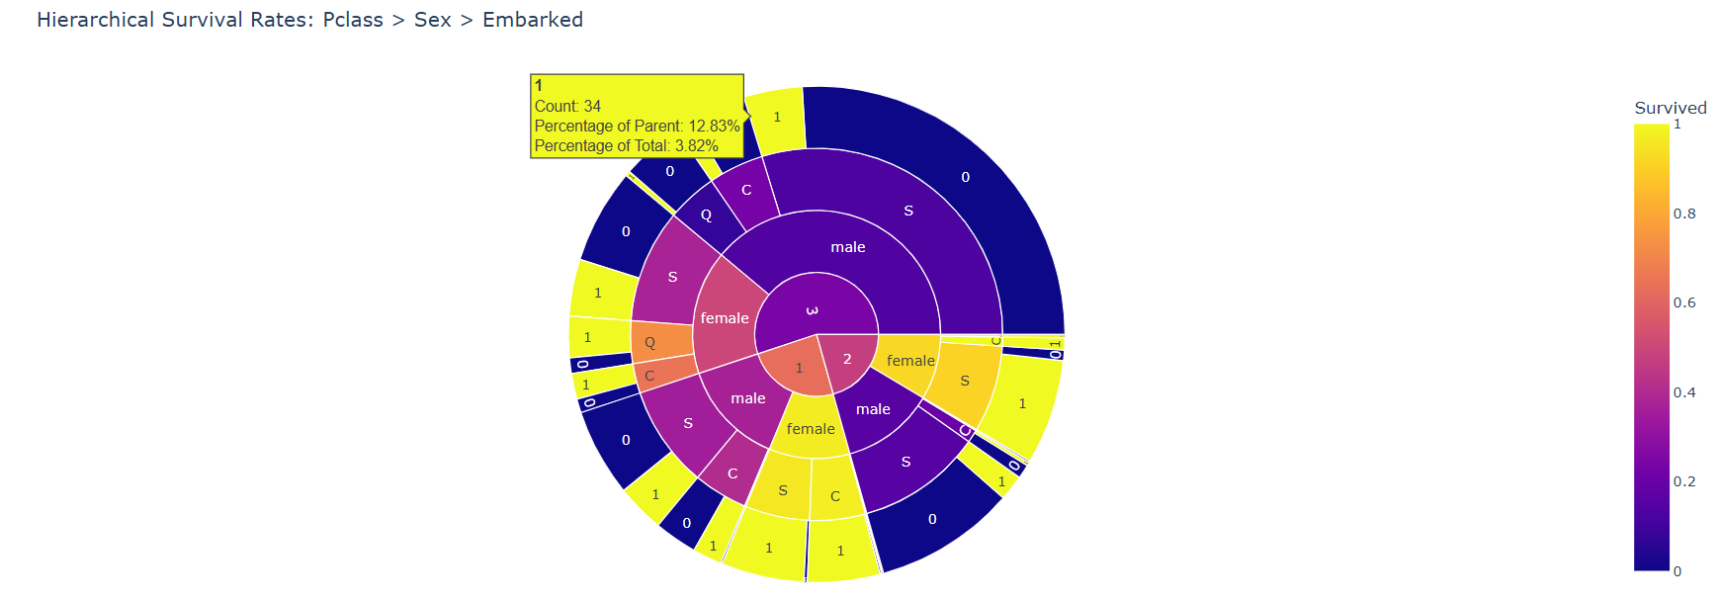

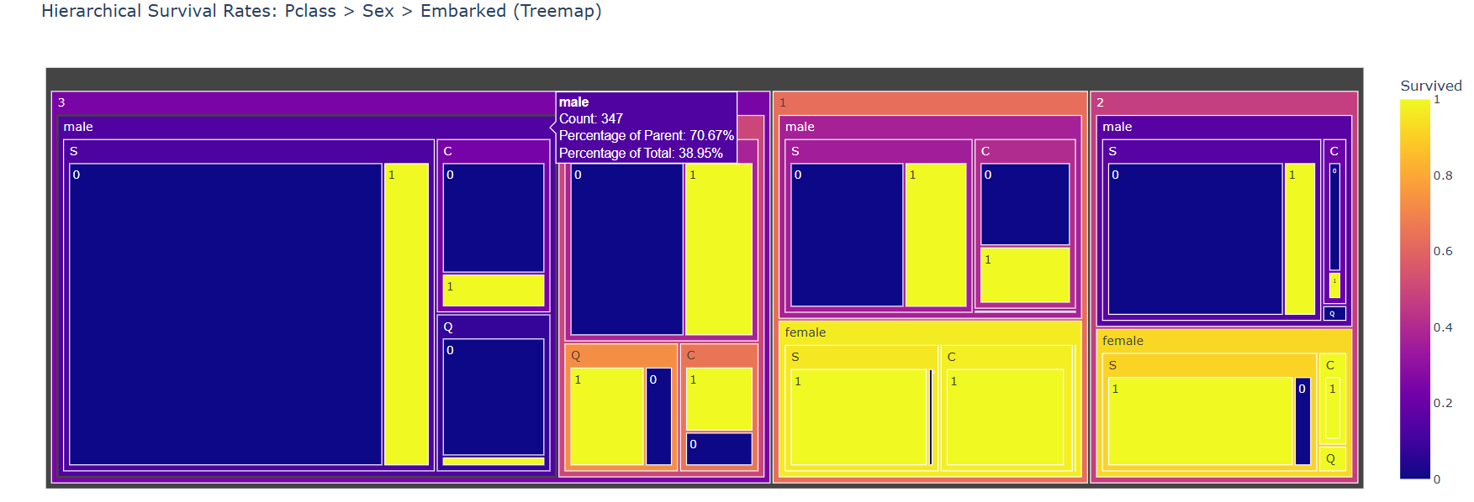

Train a Random Forest Classifier
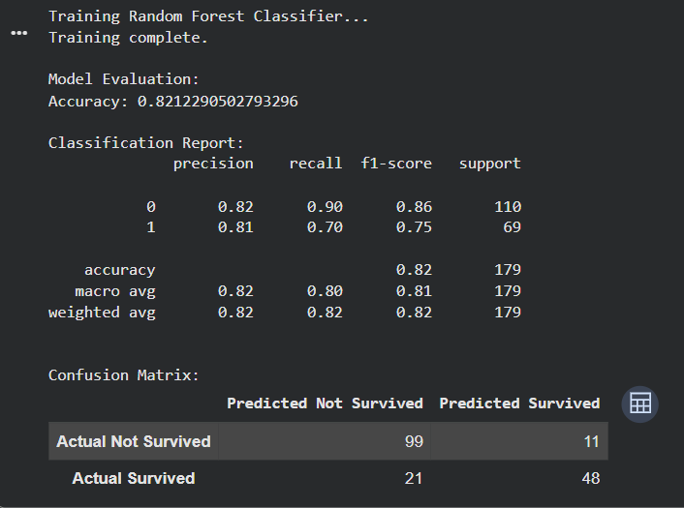
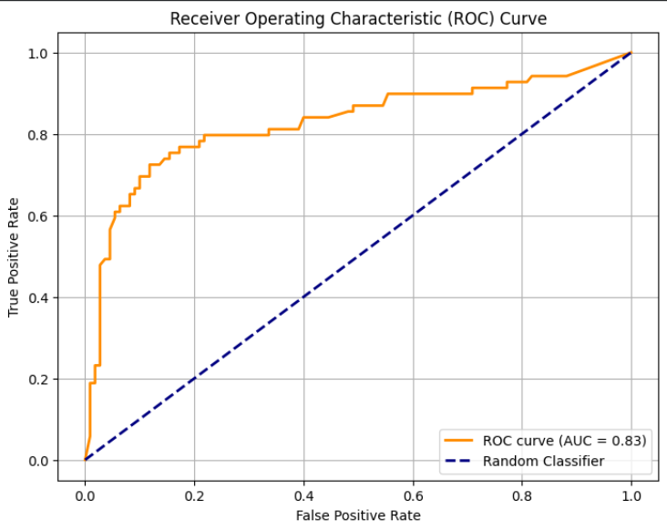
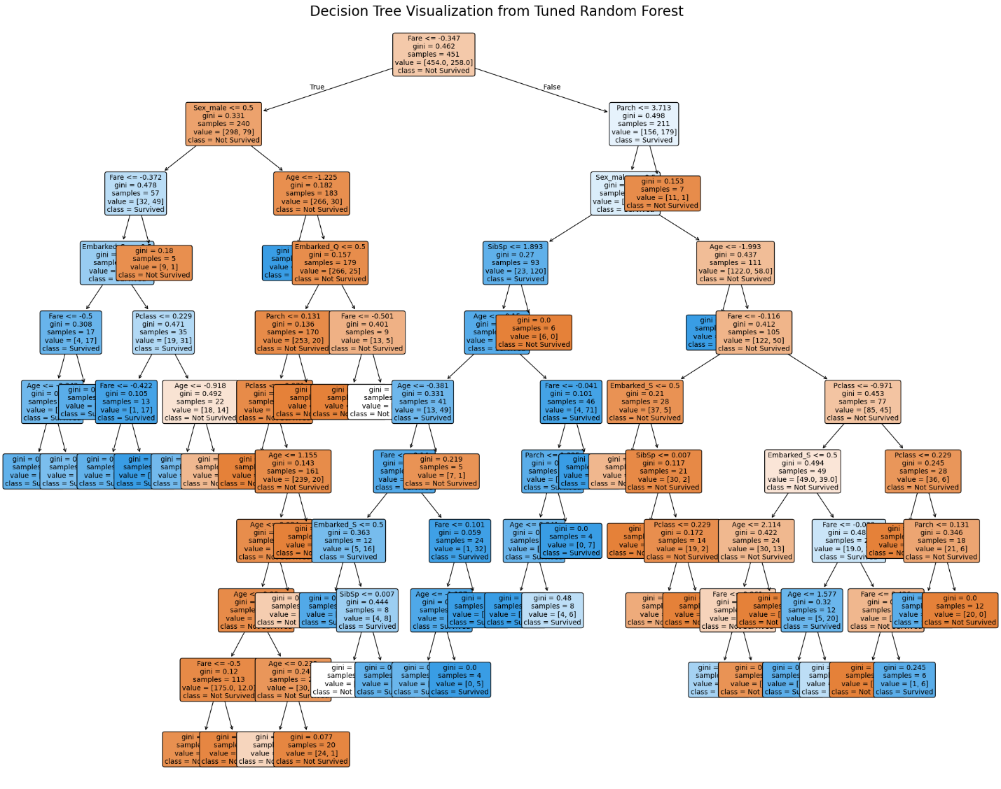

Question 2 — Wine Quality Dataset
Perform a complete data preprocessing workflow using the Wine Quality Dataset. The dataset contains numerical chemical properties of wine such as acidity, sugar, chlorides, sulphates, alcohol, and a wine-quality score.
Use Pandas and Scikit-learn to inspect, clean, transform, scale, and split the dataset. Analyze the importance of preprocessing numerical features and prepare the dataset for a Machine Learning problem.

Task Requirements
- Load the Wine Quality Dataset using Pandas.
- Explore the dataset and identify:
  - Number of records
  - Number of features
  - Feature names
  - Data types
  - Target variable
  - Missing values
  - Duplicate records
- Generate basic statistical information for the numerical features.
- Perform data cleaning:
  - Check for missing values.
  - Identify duplicate records.
  - Handle missing values where necessary.
  - Verify the cleaned dataset.
- Separate the dataset into:
  - Input features (X): chemical properties of wine.
  - Target variable (y): wine quality.
- Analyze the ranges of the numerical features using Pandas and NumPy.
- Explain why feature scaling may be required when different features have significantly different ranges.
- Apply feature scaling using:
  - StandardScaler
  - MinMaxScaler
- Compare the original and transformed feature values.
- Split the dataset into training and testing sets using train_test_split.
- Use an appropriate train-test ratio, such as:
- 80% training data
- 20% testing data
- Create a Scikit-learn preprocessing Pipeline for the numerical features.
- Ensure that preprocessing is fitted only on the training data to avoid data leakage.
- Display:
- Original dataset shape
- Training dataset shape
- Testing dataset shape
- Processed training data
- Processed testing data
- Generate at least two visualizations using Matplotlib to investigate the numerical features, such as:
- Feature distribution
- Correlation between alcohol and quality
- Relationship between acidity and quality
- Analyze the preprocessing results and explain:
- Which features required preprocessing.
- Why scaling was applied.
- How preprocessing changes the feature representation.
- Why train-test splitting is important.
- How the final processed dataset can be used for Machine Learning.

[CLO- 02, PLO-03, P4 (Execute) (WK5, EC4, and SDG 11) Rubric (Syntax, Logic, Completeness, (Outcome) Points (12)]

Rubrics:
Rubric | Exemplary (4) | Accomplished(3) | Developing (2) | Beginning (1)
Syntax points  Ability to understand and follow the rules of the programming language. | Program compiles and contains no syntax errors of the language. | Program compiles and is free from major syntactic errors. | Program compiles, but contains errors that signal misunderstanding of syntax | Program does not compile or (in a dynamic language) contains typographical errors
Logic points  Ability to specify conditions, control flow, and data structures | Program logic is correct, with no known boundary errors | Program logic is mostly correct, but may contain an occasional boundary error | Program logic is on the right track with no infinite loops, but shows no recognition of  boundary conditions | Program contains some conditions that specify the opposite of what is required (less than vs. greater than)
Completeness  Points  Ability to apply rigorous case analysis to the problem domain. | Program shows evidence of excellent case analysis, and all possible cases are handled appropriately. | Program shows evidence of case analysis that is mostly complete, but may have missed minor or unusual cases. | Program shows some evidence of case analysis, but may be missing significant cases or mistaken in how to handle some cases. | Program shows little recognition of how different cases must be handled differently.

